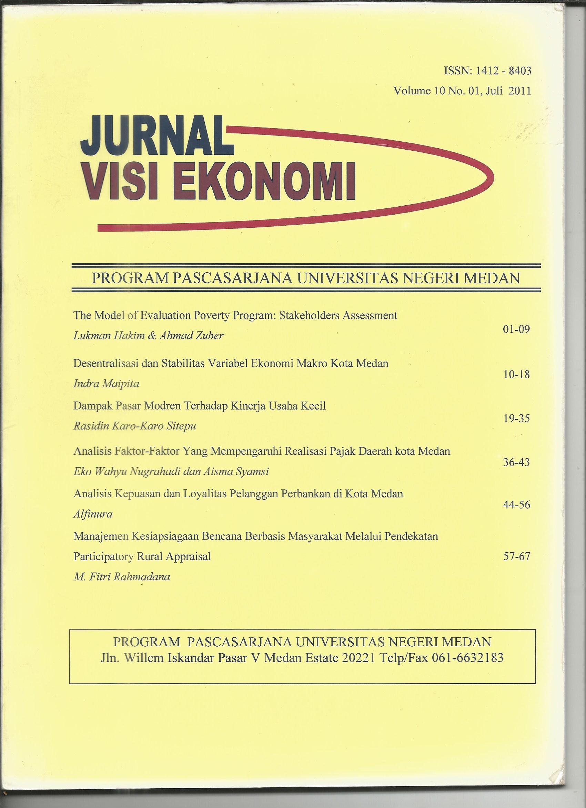
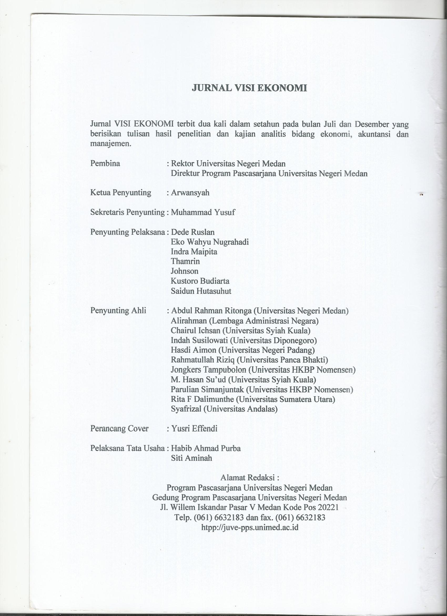
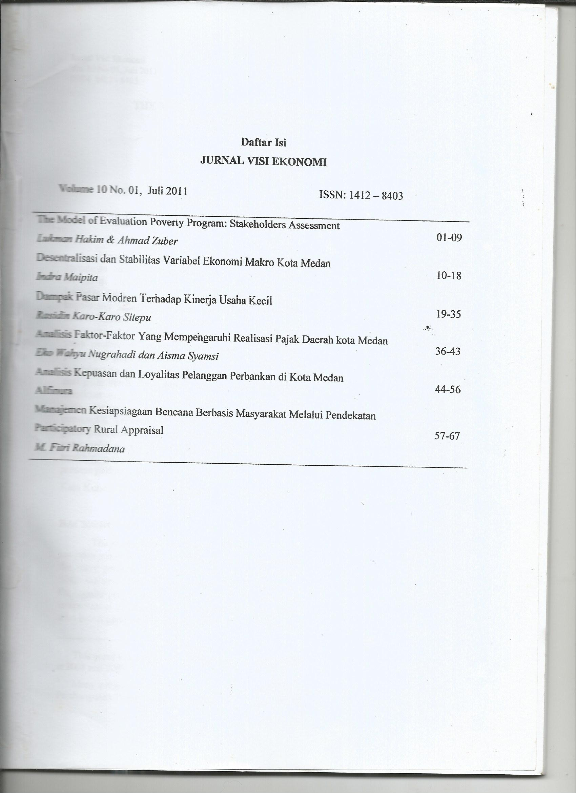
THE MODEL OF POVERTY EVALUATION PROGRAM:
STAKEHOLDERS ASSESSMENT

Lukman Hakim
Ahmad Zuber
Universitas Sebelas Maret (UNS), Solo

Abstrak
Masalah terbesar dalam implementasi program penanggulangan kemiskinan di Indonesia adalah belum tersedianya model evaluasi program secara komprehensif. Yang terjadi di lapangan justru semakin banyaknya program anti kemiskinan tanpa evaluasi kegiatan. Oleh sebab itu diperlukan penilaian dari para pemangku kepentingan (stakeholders) bagaimana sebaiknya model evaluasi itu diterapkan. Studi ini menggunakan pendekatan Proses Hirarki Analisis (AHP) dengan tujuan menguraikan masalah yang kompleks ke dalam solusi yang lebih mudah. Studi ini menganalisis dua hal didalam program anti kemiskinan yaitu preferensi kegiatan dan evaluasi. Hasil dari studi ini adalah dari sudut kegiatan pemangku kepentingan lebih memilih indikator kesejahteraan dari pada infrastruktur dan kelembagaan. Pada indikator infrastuktur, pemangku kepentingan lebih memilih transportasi dari pada listrik dan telepon. Mereka lebih memilih puskemas dari pada sekolah dan pasar, demikian pula lebih mengedepankan kegiatan langsung penanggulangan kemiskinan dari pada jaminan kesehatan maupun beasiswa sekolah. Sementara itu dari sudut evaluasi, pemangku kepentingan lebih melihat bahwa pendekatan evaluasi hendaknya bersifat pertisipatif dari pada dari bawah ataupun dari atas. Pemangku kepentingan lebih memilih jika yang melakukan evaluasi adalah penerima manfaat dibandingkan pemerintah dan LSM. Dan terakhir, mereka juga menekankan dalam proses evaluasi yang paling penting adalah prosesnya dari pada metode dan pelakunya.
Kata Kunci: Program Penanggulangan Kemiskinan, Pemangku Kepentingan.

Background
The main problem of implementation of poverty alleviation program in Indonesia has not been available of comprehensive evaluation model. This matter become important, when the more poverty alleviation programs implemented but its result is measured difficulty. Since the new order era until now the last 1980s, poverty alleviation programs integrated with the regular program development (PELITA). Along with growing of overseas aid from many international institution like World Bank and Asia Development Bank (ADB), many poverty alleviation programs operated on 1990s till this time. The many program is implemented in many district, according to Hakim et. al (2005) researched on Kota Surakarta and Sumardi et. al (2005) on Kab. Karanganyar occured often overlapping of object. Therefore, to make the sustainabality poverty alleviation needed the comprehensive evaluation model The Development Evaluation Model of Poverty Alleviation Program
Many model evaluation of poverty alleviation programs have operated some institution. Each of programs usually have guide of evaluation, but therea are closed and without particpation of stakeholders. To make the model evaluation of allevition proverty program, we purpose to indentify perception of the stakeholders in municipal level on Kab/Kota Eks Karesidenan Surakarta. We used the AHP method, because AHP get solve the complex problems become more simple analysis. We make analysis base on two problem on evaluation method. first, we will explore the successful implementation of poverty alleviation programs. Second, we will explore perception of stakeholders about criteria of model evaluation of poverty allevition programs.

Literature Review
Many poverty studies in Indonesia have conducted since decade 1970s till now. In the first generation research on poverty conducted by Singarimbun dan Penny (1976) on Desa Sriharjo, Yogyakarta This study explored rural poverty on multi discipline approaches consist of economic, social and demography aspects. Sajogyo (1978) and Esmara 91986) focused on characteristic of poverty. Sajogyo proposed to use consumption level to calculate people poorness, for rural with below 240kg/person/year and for urban 360kg/person/year, but Esmara (1986) proposed, the poverty line is calculated by a mount of people spending/year.
Meanwhile, on decade 1980s, Arief dan Sasono (1981) used the dependecia thesis to describie the poverty phenonemon in Indonesia. This analysis regarded relation between the weak countries and strong countries in the neo colonialism contect. They used the frame work by Andre Gunder Frank dan Samir Amin, for Indonesia case. This is marking the rising of new left discourse on Indonesia intellectual. The general critics of new left discourse is good on analysis, but bad on solution. Sjahrir (1986) to offer the new paradigm of development namely the basic need approach. Sjahrir argued that the basic need approach at least give the solution for the development, especially on the alleviation of poverty on the early New Order policies. He explored implementation of basic need approach policies consist of Kredit Bimas, SD Inpres, and Puskesmas.
On the early 1990s the study of poverty focused on explanation of process poverty alleviation program base on foreign aid. Sumodingirat (1990) and Kartasasmita (1997) made analysis of many poverty alleviation program consist of Program Instruksi Presiden (Inpres), Program Pengembangan Wilayah (PPW), Program Pengembangan Wilayah Terpadu Swadana (PPWT Swadana), Program Pengembangan Kawasan Terpadu (PKT) and Inpres Desa Tertinggal (IDT). In general, They argued that the program succeded to alleviate people poorness. The similar argument is told by Akita dan Szeto (2000) and Booth (2000). They found that Program Inpres Desa Tertinggal (IDT) implemented on 1994-1996 give positive impact to regional development and people welfare.
At economic crisis era, study of the poverty is more done. Studies in this era focus in the problem of calculated of people poorness consist of Pradhan, et,al (2000); Daly & Fane (2002); Alatas & Pradhan (2003); Oktaviani (2003); Alisjahbana & Yusuf (2003); Balisacan et, al (2003); Timmer (2004); Sumarto, et. al (2004); and Suryadarma, et.al (2005, 2006). Many researcher like Suryahadi, et.al (2005) dan Putro et.al (2005) present mapping of poverty in the around province and municipal of Indonesia by the GIS method. Meanwhile, Mubyarto (2000) concerns to evaluate the Jaring Pengaman Sosial (JPS) program. Hastuti (2006) evaluates BLT and SLT program, and Hakim et. al (2005) dan Sumardi et.al (2005) explore and evaluate many program of poverty alleviation in Kota Surakarta and Kab. Karanganyar
AHP method used to explore the poverty program in Indonesia. Suman (2007) evaluates implementation of Kecamatan Development Program (KDP) to society empowerment program in the East Java Province. This study to get priority of two schemes credit of KDP: the simpan pinjam khusus perempuan (SPP) and kelompok usaha ekonomi produktif (UEP). The result indicated that SPP scheme is better priority than UEP scheme. Meanwhile, Hakim (2007) focused on institutional to coordinate the poverty alleviation program in Surakarta. This study explores priority of three coordinator program: inter SKPD, Bappeda, and special institution. The findings state that respondent preferred special institution like TP2K than inter SKPD and Bappeda as coordinator of implementation of poverty alleviation program in Surakarta.

AHP Method
The Analytic Hierarchy Process is aimed at facilitating decision-making in problems which involve multiple criteria. The Analytic Hierarchy Process (AHP) is one of the most popular methods of the Multi-Criteria Decision Making (MCDM) (Saaty, 1980). In the AHP the decision problem is structured hierarchically at different levels, each level consisting of a finite number of elements. The priorities represent the relative importance of the decision elements at that level. For all levels of the hierarchy the prioritization of the elements is carried out with respect to the elements of the upper level. The elicitation of the priorities at a given level is performed by pair wise comparisons. The pair wise comparison in the AHP assumes that the decision-maker can compare any two elements and to provide a numerical value of the ratio of their relative importance. The scale for entering judgments is given in Table 1.
Additional comparison matrices are used to compare the elements of the third level with respect to the appropriate parents in the second, and so on down the hierarchy. The process could be started at the bottom level and move upward. An entry of each matrix belongs to a fundamental scale employed in the comparisons. These entries are used to generate a derived ratio scale. The next step deals with the composition of the derived ratio scales (Saaty, 1986, 1987).

Table 1
Scale of relative importance

Intensity of relative importance | Definition | Explanation
1 | Equal importance | Two activities contribute equally to the objective
3 | Moderate importance of one over another | Experience and judgment slightly favor one activity over another.
5 | Essential or strong importance | Experience and judgment strongly favor one activity over another.
7 | Demonstrated importance | An activity is strongly favored and its dominance is demonstrated in practice.
9 | Extreme importance | The evidence favoring one activity over another is of the highest possible order of affirmation.
2,4, 6, 8 | Intermediate values. between the two adjacent judgments | When compromise is needed
Reciprocals of above zero non-numbers | If an activity has of the above one numbers assigned to it when compared with a second activity, then the second activity has the reciprocal value when compared to the first.
Rationals | Ratios arising from the scale | If consistency were to be forced by obtaining n numerical values to span the matrix.
REMARK. When only two objects are compared it may be desirable to expand the interval 1, 2 (from equal to slight importance) by inserting the values, 1.1, 1.2, . . ., 1.9, starting with 1.1 as very slight, 1.2 as slight, 1.3 as moderate, etc.
Sources: Saaty, 1986

The synthesis of priorities principle is now applied. Priorities are synthesized from the second level down by multiplying local priorities by the priority of their corresponding criterion in the level above, and adding them for each element in a level according to the criteria it affects. The second level elements are each multiplied by unity, the weight of the single top level goal. This gives the composite or global priority of that element which is then used to weight the local priorities of elements in the level below compared by it as criterion, and so on to the bottom level (Wind & Saaty, 1980).
The AHP get the inconsistency problem, because the variation of many inputs. The AHP contains an intrinsic measure of inconsistency for each matrix and for the whole hierarchy. Knowledge of inconsistency enables one to determine those judgments which need reassessment. When a group uses the AHP, their judgments can be combined after discussion by applying the geometric mean to the judgments which derives from the requirement that the collective judgment itself must satisfy the reciprocal property. AHP give the tolerance of inconsistency index until 10% (Saaty, 1986).
To estimate the priority and inconsistency index on AHP method, we used the new Saaty’s program (2003) namely The SuperDecisions, and to calculate the geometric mean used the microsoft excel program. The data get from the questionnaire of a mount of the respondent is 33 key persons of stakeholders consist person from Bappeda or dinas, NGOs, and academicians of Surakarta, Boyolali, Sukoharjo, Karanganyar, Wonogiri, Sragen, and Klaten.

The Result and Analysis
1. The Successful Implementation of Poverty Alleviation Programs.
In this part, we explored the successful implementation of the poverty alleviation program. This model explored priority of decision maker on three indicator; infrastructure, institution, and welfare. Criteria of infrastructure indicators are transportation access, electricity customer (PLN), telephone customer (Telkom). Criteria of institutions indicator are market, hospital and school. Criteria of welfare are a mount of poverty family, grantee, and health security beneficiary. The hierarchy presented the following picture.

.

Hierarchy of the Successful Implementation of Poverty Alleviation Programs

The Successful Implementation of Poverty Alleviation Programs
Goal :

Criteria:
- Transportation access
- Electricity customer
- Telephone customer

- Market
- Rural Hospital
- School

- Poverty family
- Grantee
- Healthy security

Alternatives:

Welfare
Indicators
Institution
Indicators
Infrastructure
Indicators

Table 2 Estimation Result

No. | Infrastructure Criteria |  | Synthesize | Consistency | Rangking
1 | Transportation access |  | 0.522146 | Consistent | I
2 | Electricity customer |  | 0.331524 | Consistent | II
3 | Telephone customer |  | 0.146331 | Consistent | III
Inconsistency index = 0.0379 (< 0.1 atau < 10%)
 | Institutions Criteria |  | Synthesize | Consistency | Rangking
1 | Market |  | 0.166472 | Inconsistent | III
2 | Rural Hospital |  | 0.445198 | Inconsistent | I
3 | School |  | 0.388329 | Inconsistent | II
Inconsistency index = 0.1257 (< 0.1 atau < 10%)
 | Welfare Criteria | Synthesize |  | Consistency | Rangking
1 | Poverty family | 0.474948 |  | Consistent | I
2 | Grantee | 0.172376 |  | Consistent | III
3 | Health security | 0.352676 |  | Consistent | II
Inconsistency index = 0.0616 (< 0.1 atau < 10%)
 | Alternatives | Synthesize |  | Consistency | Rangking
1 | Infrastructure indicators | 0.203831 |  | Consistent | II
2 | Institutions indicators | 0.143793 |  | Consistent | III
3 | Welfare indicators | 0.652377 |  | Consistent | I
Inconsistency index = 0.0272 (< 0.1 atau < 10%)

The stakeholders preferred transportation access (0,52) than electricity customer (0,33) and telephone customer (0,14) on the infrastructure criteria. Meanwhile, they preferred rural hospital (0,44) than school (0,35) and market (0,16) on the institutions criteria. They preferred to focus on poverty family (0,47) than heath security (0,35) and grantee (0,17) on the welfare criteria. And the last result, they preferred welfare (0,65) than infrastructure (0,20) and institutions indicators (0,14).

.

Hierarchy of the Evaluation Model of Poverty Alleviation Programs

The Evaluation Model of Poverty Allevition Program
Tujuan :

Kriteria
- Bottom Up
- Participation
- Top down

Alternatif
- Government
- NGOs
- Benefit receiver

- End Program
- Periodical
- Mid Program

2. The Model Evaluation of Poverty Alleviation Programs.
Evaluation Process
Evaluation Actors
Evaluation Method
In this part, we explored the model evaluation of poverty alleviation programs. This model explored priority of decision maker on three main approach of evaluation; method, actors, and process. Criteria of method are bottom up, participation and top down. Criteria of actors are government, NGOs, and benefit receiver. Criteria of process are end program, periodical, and mid program. The hierarchy presented the picture above.

Table 3 Result of The Estimation

No | Method |  | Synthesize | Consistency | Peringkat
1 | Bottom Up |  | 0.261571 | Consistent | II
2 | Participation |  | 0.582744 | Consistent | I
3 | Top Down |  | 0.155686 | Consistent | III
Inconsistency index = 0.0203 (< 0.1 atau < 10%)
No | Actors |  | Synthesize | Consistency | Peringkat
1 | Government |  | 0.338678 | Consistent | II
2 | NGOs |  | 0.205665 | Consistent | III
3 | Benefit Receiver |  | 0.455657 | Consistent | I
Inconsistency index = 0.0218 (< 0.1 atau < 10%)
No | Process |  | Synthesize | Consistency | Peringkat
1 | End Program |  | 0.150041 | Consistent | III
2 | Periodical |  | 0.528561 | Consistent | I
3 | Mid Program |  | 0.321397 | Consistent | II
Inconsistency index = 0.0082 (< 0.1 atau < 10%)
No. |  | Alternatives | Synthesize | Consistency | Peringkat
1 |  | Evaluation Method | 0.360269 | Consistent | II
2 |  | Evaluation Actors | 0.268168 | Consistent | III
3 |  | Evaluation Process | 0.371563 | Consistent | I
Inconsistency index = 0.0272 (< 0.1 atau < 10%)

The stakeholders preferred participation (0,58) than bottom up (0,33) and top down (0,14) on the method criteria. Meanwhile, they preferred benefit receiver (0,44) than government (0,35) and NGOs actors criteria. They preferred periodical (0,52) than mid program (0,32) and end program (0,15) on the process criteria. And the last result, they preferred process (0,37) than evaluation method (0,36) and actors (0,26).

Conclusion
This paper explore two evaluaton problem on poverty alleviation program. First, the evaluation of successful implementation of poverty alleviation programs. Second, we will explore perception of stakeholders about creteria of development model on model evaluation. On the evaluation of successful implementation of poverty alleviation programs, stakeholders preferred transportation access than electricity customer and telephone customer on the infrastructure criteria. They preferred rural hospital than school and market on the institutions criteria. They preferred to focus on poverty family than heath security and grantee on the welfare criteria. And the last result, they preferred welfare than infrastructure and institutions indicators. Meanwhile, on the model evaluation of poverty alleviation programs, the stakeholders preferred participation than bottom up and top down on the method criteria. They preferred benefit receiver than government and NGOs actors criteria. They preferred periodical than mid program and end program on the process criteria. And the last result, they preferred process than evaluation method and actors. Base on these preferences of stakeholders, we can develop the new evaluation model of poverty alleviation model.

References
Akita, T & Szeto J.J.K.. (2000). “Inpres Desa Tertinggal (IDT) Program and Indonesian Regional Inequality”. Asian Economic Journal. Vol. 14. No.2.
Alatas, V & Pradhan, M. (2003). “Geographic Targeting in Indonesia”. The 5th IRSA International Conference, “Regional Development in a Decentralized Era: Public Service, Poverty, and the Environment”, July 18-19, Bandung.
Alisjahbana, A.S & Yusuf, A.A. (2003). “Poverty Dynamics in Indonesia: Preliminary Evidence from Longitudinal Data”. The 5th IRSA International Conference, July 18-19, Bandung.
Arief,S & Sasono. A.(1981). Indonesia: Ketergantungan dan Keterbelakangan. Jakarta: Lembaga Studi Pembangunan.
Asselin, L.M & Dauphin. A. (2001).”Poverty Measurement: A Conceptual Framework.” Working Paper Canadian Centre for International Studies and Cooperation (CECI).
Balisacan, A,M, Pernia EM, & Asra A. (2003). “Revisiting Growth and Poverty Reduction in Indonesia.” Bulletin of Indonesian Economic Studies, 39(3), December, pp.329-353.
Booth, A. (2000). ”Poverty and Inequality in the Soeharto Era: An Assessment.” Bulletin of Indonesian Economic Studies, 36(1), April.
Daly, A. & Fane, G (2002). “Anti-Poverty Programs in Indonesia.” Bulletin of Indonesian Economic Studies, 38(2), December.
Denzin, N. K & Lincoln Y.S. (1994). Handbook of Qualitative Research. London: SAGE Publication.
Esmara, H. (1986). Politik Perencanaan Pembangunan: Teori, Kebijaksanaan, dan Prospek. Gramedia, Jakarta.
Hakim, L (2007). “Pandangan Para Pembuat Kebijakan Terhadap Program Penanggulangan Kemiskinan di Kota Surakarta: Penerapan Metode AHP.” Region, 2 (1) 35-42.
Hakim, L, Daerobi, Sumardi. (2005). ”Kajian Pemetaan dan Sinkronisasi Program Penanggulangan Kemiskinan di Kota Surakarta 2005.” Laporan Penelitian, PPEP FE UNS, Bapeda Kota Surakarta, dan Kantor Komite Penanggulangan Kemiskinan (KPK) Jakarta.
Hastuti, Nina Toyamah, Syaikhu Usman, Bambang Sulaksono, Sri Budiyati, Wenefrida Dwi Widyanti, Meuthia Rosfadhila, Hariyanti Sadaly, Sufiet Erlita, R. Justin Sodo, Sami Bazzi, Sudarno Sumarto. (2006). “Kajian Cepat Pelaksanaan Subsidi Langsung Tunai Tahun 2005 di Indonesia: Studi Kasus di Lima Kabupaten/Kota.” Smeru Working Paper, January.
Hill, H (ed). (1989).Unity and Diversity: Regional Economic Development in Indonesia Since 1970. Singapore: Oxford University Press.
Kartasasmita, G. (1997). “Power dan Empowerment: Sebuah Telaah Mengenai Konsep Pemberdayaan Masyarakat”, Perencanaan Pembangunan, No. 07. Januari.
Mubyarto. (2000). Membangun Sistem Ekonomi. Yogyakarta: BPFE.
Oktaviani, D. (2003). “Inflasi, Pengangguran dan Kemiskinan di Indonesia: Analisis Indeks FGT.” Media Ekonomi, 9(3), Desember.
Pernia, E, M & Quibra, MS. (1999). “Poverty in Developing Countries.” Dalam Paul Cheshire dan Edwin S. Mills. Handbook of Regional and Urban Economics Vol 3. Amsterdam: Elseiver.
Pradhan, M, Suryahadi A, Sumarto S & Pritchett L. (2000). “Measurements of Poverty in Indonesia: 1996, 1999, and Beyon”. World Bank Working Paper Policy Research No.2438., September.
Putro, RT & Jati, H.S. (2005). “Upaya Pengentasan Kemiskinan di Pulau Jawa dan Bali 2003”. Paper dipresentasikan dalam Dies ke-25 Program MSi FE UGM.
Ravallion, M. (2005). “Evaluating Anti-Poverty Program.” World Bank Policy Research Working Papers 3625, June.
Saaty, T.L .(1980). The Analytic Hierarchy Process. New York: Mc Graw-Hill
Saaty, T.L. (1986). “Axiomatic Foundation of the Analytic Hierarchy Process.” Management Science, 32(7): 841-855
Saaty, R.W. (1987). “The Analytic Hierarchy Process: What it is and How it Used”. Math Modeling, 9:161-176.
Saaty, R.W. (2003). Decision Makin in Complex Environments: The Analytic Hierarchy Process (AHP) for Decision Making and The Analytic Network Process (ANP) for Decision Making with Dependence and Feedback. The Handbook of SuperDecision. Pittsburgh: Creative Decisions Foundation.
Sachs, J. D, Bajpai N, & Ramiah, A. (2002). “Understanding Regional Economy Growth in India.” Center for International Development (CID) Harvard University No.88, March.
Sajogyo. (1978).”Lapisan Masyarakat yang Paling Lemah di Perdesaan Jawa.” Prisma, No 3.
Schiller, B.R. (1998). The Economics of Poverty and Discrimation. New Jersey: Prentice Hall.
Sen, A & Foster J. (1997). On Economic Inequality. Oxford: Oxford University Press.
Singarimbum, M & Penny D. (1976). Penduduk dan Kemiskinan: Kasus Sriharjo di Pedesaan Jawa. Jakarta: Bhratara Karya Aksara.
Sjahrir. (1986). Ekonomi Politik Kebutuhan Pokok: Sebuah Tinjauan Prospektif. Jakarta: LP3ES.
Sumodiningrat, G. (1990). “Pemerataan Pembangunan.” Makalah disampaikan pada Kongres ISEI ke XI, Bandung, 22-25 Agustus.
Suman, A (2007). ”Pemberdayaan Perempuan, Kredit Mikro and Kemiskinan: Sebuah Studi Empiris.” Jurnal Manajemen dan Kewirausahan 9(1) 62-72
Sumardi, Sumantyo R, Hakim, L. (2005). ”Evaluasi Program Penanggulangan Kemiskinan di Kabupaten Karanganyar Tahun 2005. Laporan Penelitian, PIPW LPPM UNS dan Bapeda Kab. Karanganyar.
Sumarto, S, Suryahadi A, & Arifianto, A. (2004).”Governance and Poverty Reduction: Evidence from Newly Decentralized Indonesia.” Smeru Working Paper. March.
Suryadarma D, Artha R.P, Suryahadi A, Sumarto S. (2005). “A Reassessment of Inequality and its Role in Poverty Reduction in Indonesia.” Smeru Working Paper. January.
Suryadarma, D, Widyanti W, Suryahadi A, Sumarto S. (2006). “From Acces to Income: Regional and Ethnic Inequality in Indonesia.” Smeru Working Paper, May.
Suryahadi, A Widyanti W, Artha R.P, Perwira D, Sumarto S. (2005). “Developing a Poverty Map for Indonesia: A Tool for Better Targeting in Poverty Reduction and Social Protection Programs (Book 1: Technical Report)”. Smeru Working Paper. February.
Timmer, P.C. (2004). “The Road to Pro-Poor Growth: The Indonesian Experiences in Regional Perspective.” Bulletin of Indonesian Economic Studies, 40(2), August.
Wind, Y & Saaty T. L. (1980). “Marketing Applications of the Analytic Hierarchy Process.” Management Science, 26(7) 641-658

This paper is a part of report of Competitive Research Grant (Hibah Bersaing) from DP2M Dikti, at 2008 and 2009
Many programs is Inpres Desa Tertinggal (IDT), Program Pengembangan Kecamatan (PPK), Pembangunan Prasarana Pendukung Desa Tertinggal (P3DT), Program Penanggulangan Kemiskinan Perkotaan (P2KP), Pemberdayaan Daerah Mengatasi Dampak Krisis Ekonomi (PDMDKE), Jaring Pengaman Sosial (JPS), Beras Miskin (Raskin) dan Bantuan/ Subsidi Langsung Tunai (BLT/SLT).

